Food order in train

Real Price Zomato Price

Mani Teja Fast Food Mani Teja Fast Food

Chicken Fried Rice = (Rs110) Chicken Fried Rice = (Rs180)

(Proof Pg. No: 3)

Order is taken Delivery Boy

Bike Delivery Boy = (Rs10)

Order is Delivery Restaurants to Railway Station Counter

Railway Station Counter = (Rs10)

Railway Station Counter Add the PNR Tag to Order Send to Platform Delivery Boy

Railway Platform Delivery Boy = (Rs10)

Platform Delivery Boy Delivery the Order Based Upon PNR Details

Delivery To Order Person in Train Seat

|  |  |
| --- | --- |
| One order (Rs180) | |
| Real Price and Delivery Charges | Item total Price |
| Restaurants Price = Rs 110 | Item Price = Rs 180 |
| Bike Delivery Boy = Rs 10 | Railway services = Rs 7% =12.6 |
| Railway Station Counter = Rs 10 |  |
| Railway Platform Boy = Rs 10 |  |
| IRTC = Rs 5 |  |
| India Railways = Rs 5 |  |
| Total Price = Rs 150 | Total Price = Rs 192.6 |
| Profit = 192 - 150 = Rs 42 | |

Per Order Profit = Rs 30

Per Train Passengers = 100 Persons

No of Trains = 5000

30 x 100 x 5000 = 1,50,00,000 Per Day (1.5Crore)

1,50,00,000 x 30 = 45,00,00,000 Per Month (45 Crores)

Note: Above calculations are taken from Wikipedia not more than below averages

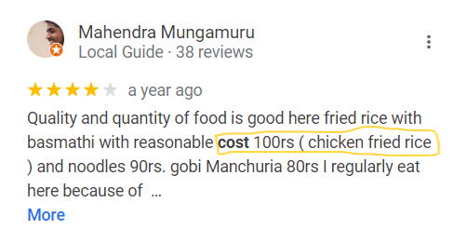Google Maps reviews

Zomato Page :

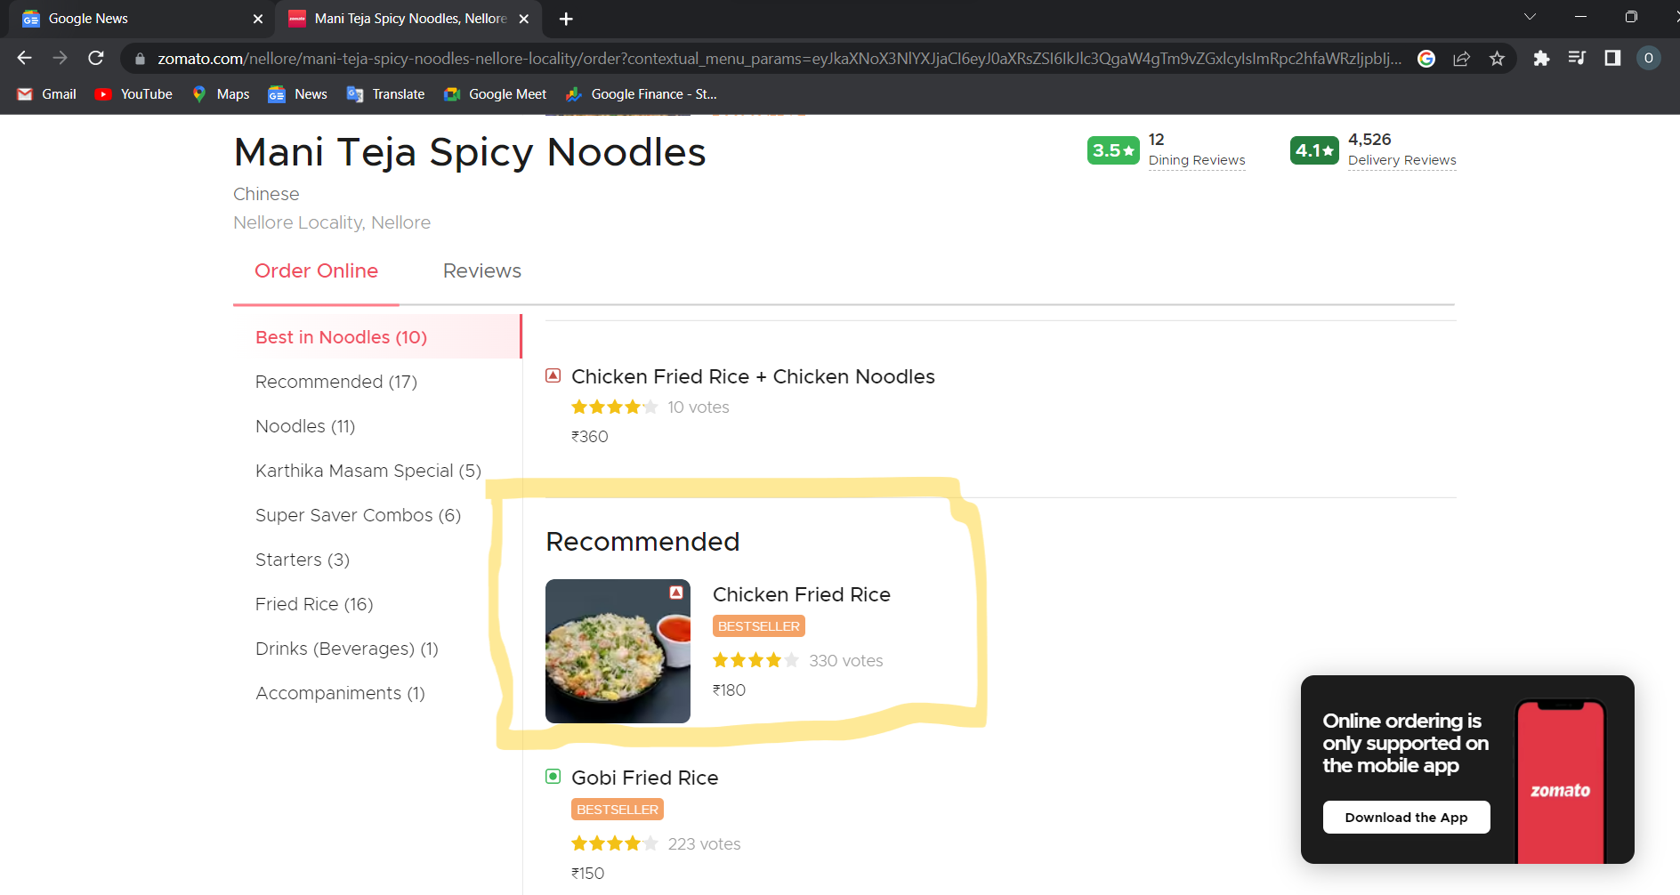

* How many trains travel per day in India?

It runs **13,169** passenger trains daily, on both long-distance and suburban routes, covering **7,325** stations across India.

[https://en.wikipedia.org/wiki/Indian_Railways#:~:text=It%20runs%2013%2C169%20passenger%20trains,covering%207%2C325%20stations%20across%20India.](https://en.wikipedia.org/wiki/Indian_Railways%23:~:text=It%20runs%2013%2C169%20passenger%20trains,covering%207%2C325%20stations%20across%20India.)

* What is the passenger capacity of a train, generally?
* general class coaches - 4, (As many passengers can travel - may be 300)
* Sleeper class coaches - 11 (72 berths * 11 =792)
* Third AC-3 (64 berths * 4 = 256)
* Second AC - 2 (46 berths * 2 = 92)
* First AC - 1 or NIL. (24 berths * 1 = 24)
* **Total comes to - 1464 passengers**
* And don’t forget to add Tatkal waitlisted passengers.